Go to eclipse

Make a new class and write a method to return a sum

Then go to new project, Junit test case (if not there then serch)

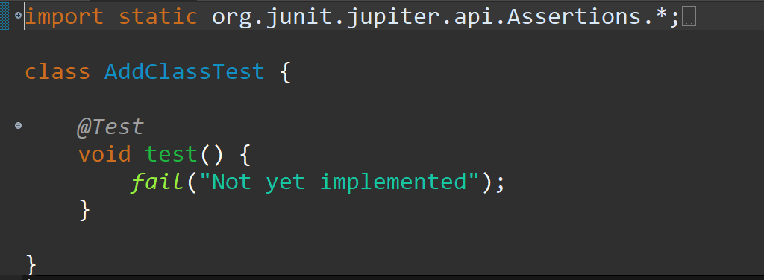

Right click run as junit test case

Red 🡺 failed

Green 🡺 passed

DEFAULT STATE OF TEST IS : \*PASS\*

ASSERT : check of epected and actual are equal

ASERT FUNTIONS : expected and actual value

Make a new method in the test class void testAdd

Make a new object of that addClass

Declarte var for expected value, Int expected value = 6